INSTRUCTION TO CHANGE YOUR EMAIL SIGNATURE
- Once you open Outlook click on „New email“.
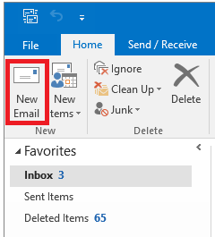
- In the upper line find and click on „Signature“ and choose „Signatures…“.
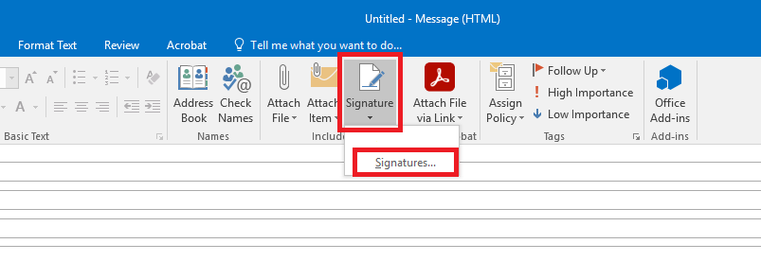
- In the new window that opens click “New”, name your new signature VILNIUS TECH and select “OK”. In the text box below type this text:
Best regards
First and last name
Position
The name of department
Vilnius Gediminas technical university – VILNIUS TECH
e-mail name.surname@vilniustech.lt
Phone number of department
Mobile phone number
This e-mail and any of the attachments are for the exclusive use of the intended recipient. The content of this e-mail and any of attachments is confidential. If you are not an intended recipient or you have received this email by error, we hereby notify you that any disclosure, copying, distribution, or any other use of this information is strictly prohibited. Kindly inform the sender about this e-mail and delete the e-mail and any attachment without retaining copies.

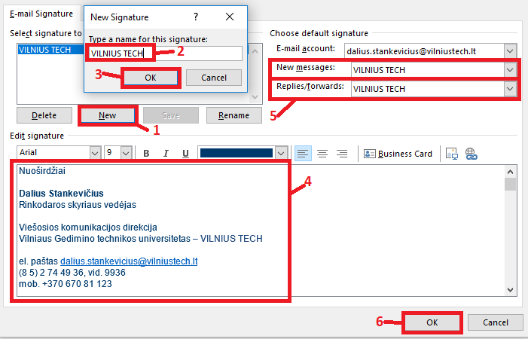
- In the sections „New messages“ and „Replies/forwards“ select VILNIUS TECH and click „OK“.
- Choose one of these photos below. Select the photo and click “Copy” (CTRL + C), go back to the text box in Outlook and click “Paste” (CTRL + V).

